Practical Work document – Session 5
Position indicators - values relative to a percentage

Exercise 1 (individual work to be carried out during the course)
Context:
The pedagogical manager of the mathematics module, at U University, carried out a study with 45 people chosen at random from first-year students.
In the context of this study, the pedagogical leader of the mathematics module recorded for each participant his or her score (out of 20) on the intermediate exam and his or her score (out of 20) on the continuous assessment. Note that these exams took place during the first semester of the current year.
The data (in the raw state) of each variable studied, are accessible via Moodle in the section dedicated to session 5 (file " PW - Session 5.xlsx" Sheet entitled: semester 1)
Mission 1.1 :
After carefully reading Appendix 1 and Appendix 2, students are asked to:
- Complete Table 1
- Draw the box plot associated with the data for the variable "Mid-Term Exam".
Mission Objective:
- Identify the existence of extreme values (analytically and graphically (via the box plot))

Exercise 2 (individual work to be carried out outside the course)
Take the statement from Exercise 1, to complete the missions below.
Mission 2.1 :
After carefully reading Appendix 1 and Appendix 2, students are asked to:
- Complete Table 2
- Draw the box plot associated with the data for the variable "continuous assessment".
Mission Objective:
- Identify the existence of extreme values (analytically and graphically (via the box plot))
To go further :
Using Appendix 2 as a guide, draw on the same graph the box plots associated with the data for the two variables ("Mid-Term exam grade" and "Continuous assessment grade")
Interpret the resulting graph.
Exercise 3 (individual work to be carried out during the course)
The pedagogical manager of the mathematics module, at U University, carried out a study with 45 people chosen at random from first-year students.
In the context of this study, the pedagogical leader of the mathematics module recorded for each participant his or her score (out of 20) on the intermediate exam and his or her score (out of 20) on the continuous assessment. Note that these exams took place during the second semester of the current year.
The data (in the raw state) of each variable studied, are accessible via Moodle in the section dedicated to session 5 (file " PW - Session 5.xlsx" Sheet entitled: semester 2)
Mission 3.1 :
After a careful reading of the course and building on the skills acquired during the Practical Work in session 3, students are asked to:
- Complete Tables 1 and 2
Mission 3.2 :
After carefully reading Appendix 3, students are asked to:
- Draw the box plot associated with the data for the variable "Mid-Term Exam".
Mission Objective:
- Identify the existence of extreme values (analytically and graphically (via the box plot))
Exercise 4 (individual work to be carried out outside the course)
the statement from Exercise 3, to complete the missions below.
Mission 4.1 :
After a careful reading of the course and building on the skills acquired during the Practical Work in session 3, students are asked to:
- Complete Tables 3 and 4
Mission 4.2 :
After carefully reading Appendix 3, students are asked to:
- Draw the box plot associated with the data for the variable "Continuous Assessment".
Mission Objective:
- Identify the existence of extreme values (analytically and graphically (via the box plot))
Appendix 1 : The function quartile
The function QUARTILE is predefined in Excel. Of course, it allows you to calculate quartiles when the data is in its raw state. So, this function needs the range of cells that contains the data, and then a parameter. Note that :
- If you set this parameter to 1, the function gives you the value of the first quartile
- If you set this parameter to 2, the function gives you the value of the median
- If you set this parameter to 3, the function gives you the value of the third quartile
Remarks:
- If you set this parameter to 0, the function gives you the smallest observation. This value can be obtained by using the function MIN
- If you set the value of this parameter to 4, the function gives you the largest observation. This value can be obtained by using the function MAX
Appendix 2 : Create the box plot (with Excel 2016, 2019 and Office 365) when the data is in its raw state
When the data is in its raw state, Excel 2016, 2019 and Office 365 allow you to create the boxe plot in a very simple way. Explicitly, to get this chart, you just need to:
- Select the data on which you want to create a box plot.

- Then click Insert > Insert Recommended Charts > All Charts > Box and Whisker

- Explore the chart options for better formatting (title / colors / labels / ...)

Appendix 3 : Create a box plot with an older version of Excel or when the data provided is already summarized in a table
If you do not have Excel 2016 or Excel 2019 or Office 365 or if the data provided is not in its raw state (i.e. it is summarized in a table), then the creation of the box plot is not automatic (see Appendix 2). In the rest of this section, we will detail, through an example, a particular trick that allows to build the box plot in this case.
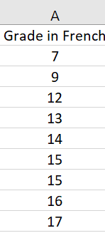
Suppose that we have in a column the grades in French of 9 high school students

To build the box plot associated with the above data, you have to perform several steps:

- Step 1 : calculation of quartiles (see Appendix 1), pivots, and limits
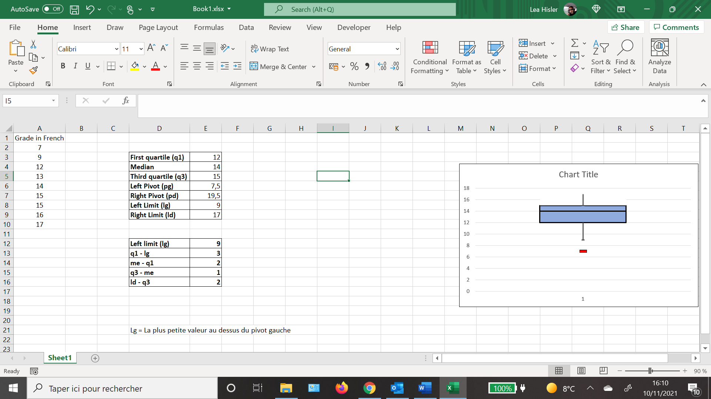

- Step 2: Construct the following table of differences:

- Step 3 Creation of the box plot
  - Select the previous table
  - Insert a Stacked Column (Insert 2-D Column >Stacked Column)
  - 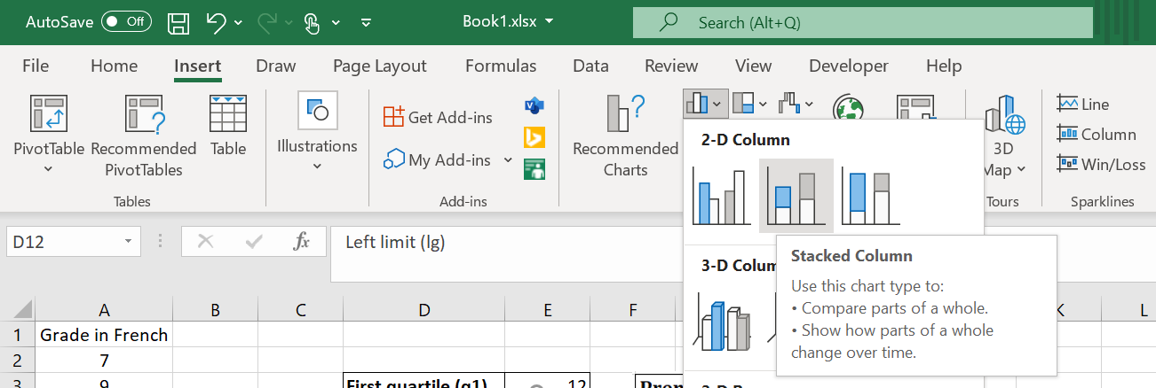

  - Click on switch row/column:
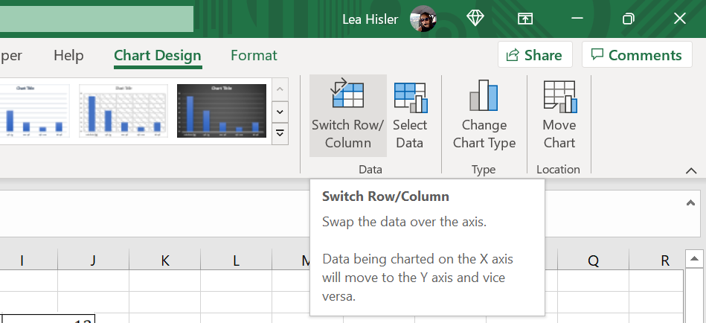

  - Right click on the lowest rectangle of the graph No fill

- Step 4 : creation of the whiskers

- Right click on the topmost rectangle of the graph No fill

- Click on chart tools Chart Element Errors Bars Percentage

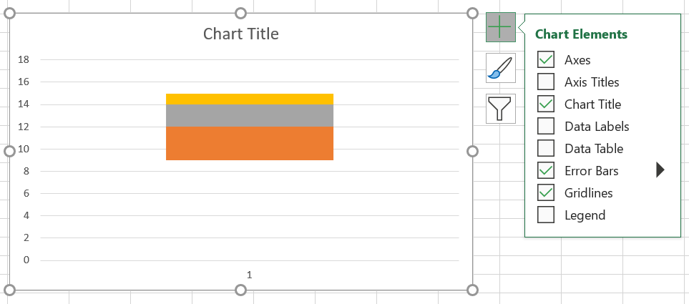

- Right Click on the bar creation Format Error Bars
In the window that has just opened select:
Direction: Minus / End Style: Cap / Error Amount : Percentage = 100%
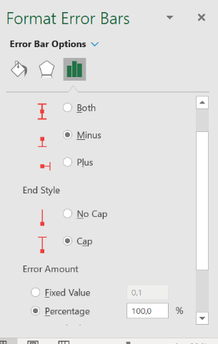

- Repeat the three previous steps on the lowest rectangle (orange color).

- Step 5 : box formatting
    - Right click on the top rectangle Fill in the desired color (for example blue)
    - Click on Border choose the color (black)
    - Go to the right window Solid Line Width 1,5 pt

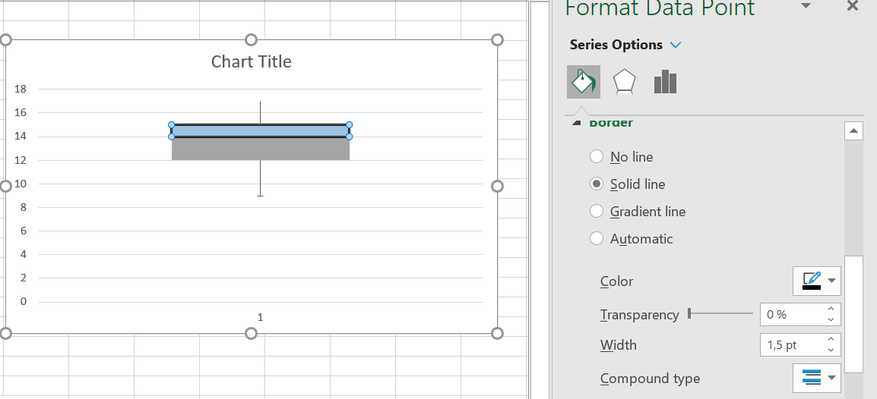

    - Do the same for the bottom rectangle and for the whiskers

- Step 6 : representation of extreme values (if they exist)
Note that in our example, there is only one extreme value (the one that goes outside the limits of the box plot). This extreme value corresponds to the grade of 7. This value can be represented graphically with a symbol (e.g. square) using the text box.

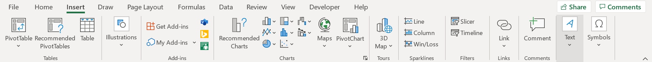

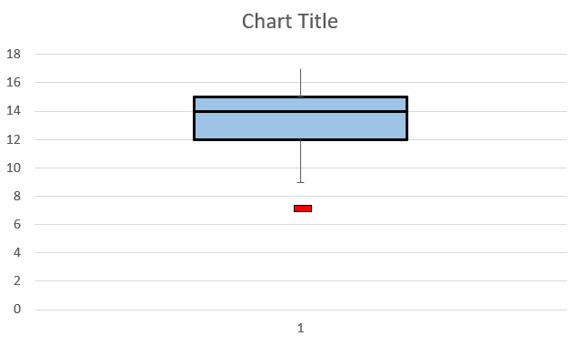

- Step 7: Explore the chart options for better formatting (title / colors / labels / ...)

